Chapter 3
Bayesian and instance based learning
Probability theory and Bayes rule
Classifying with Bayes decision theory
Conditional Probability
Bayesian Belief Network
K-nearest neighbor

Conditional Probability
The conditional probability of an event A is the probability of an event ( A ), given that another event ( B ) has already occurred.
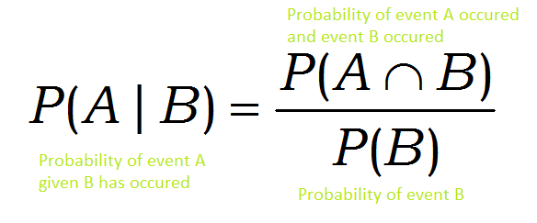
I want you to read the definition and go through the above formula once more. Appreciate each term in the formula and try to create a mental picture of the same. Don’t get intimidated by the symbols. By end of this article, you will be able to understand what this equation really means and how you can intuitively come up with the same equation without just memorizing it.
Okay. To understand the concept of conditional probability, let us begin with the concept of independent and dependent events.
Independent events are events that do not affect the outcome of each other. In terms of probability, two events are independent if the probability of one event occurring no way affects the probability second event occurring.
For example, consider two events, the probability of raining today and brushing your teeth. Both of them can be considered independent events, with the probability of them occurring, do not affect each other.

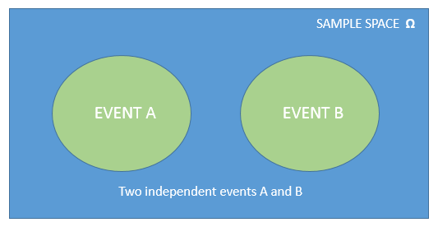
On the other side, events are said to be dependent if the probability of one event occurring affects the probability of other event occurring.

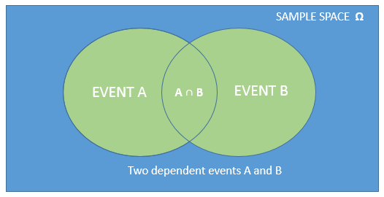
Here A ∩ B represents the event A occurred and B also occurred
Conditional probability is a tool for quantifying dependent events.
If two events are independent, then the process of calculating the conditional probabilities of events are simple and straightforward.
The conditional probability of event A occurring given event B has occurred, if they are independent events is,
P(A|B) = P(A)
Can you think why?
Okey. Now let’s see the case where the two events are dependant on each other.
Imagine that you are on your way to San Francisco for your first machine learning job and you need to catch a connecting flight from New York to reach San Francisco. As a machine learning engineer, you know that the world is full of uncertainties.

You are on your way to San Francisco for your first machine learning job. Will you reach on time? Lets see the odds using probability.
So you consider two events
Event A: The probability that you will miss your connecting flight. Let its value be 0.40 ie there is a 40 percent chance for you to miss your connecting flight.
P(A) = 0.40
Event B: The probability that your flight will be late. Let its value be 0.20 ie there is a 20 percent chance for your current flight to be late.
P(B) = 0.20
Here we have assigned independent probabilities to the two events A and B which are respectively 0.40 and 0.20. This is based on your assumptions or previous knowledge.
But you know intuitively that there is far more chance of missing your connection flight (event A), if your current flight is late(event B). In that case, will you stick to your initial assumption 40 percent chance of missing your connecting flight?
No. You cannot because, the probability(chance) of missing the connection flight increases if your current flight is also late. So you need to reconsider by probability numbers and update it accordingly. At this point what do you think about the probability of event A? Will it increase or decrease?

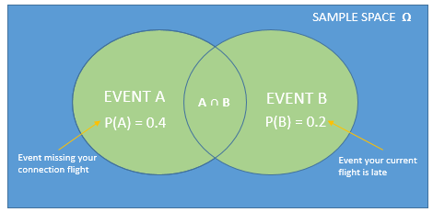
Conditional probability helps us calculate exactly the same. The above Venn diagram represents your current assumptions.
Now let’s consider the unfortunate case that your current flight is late ie the event B has occurred. What does that mean to the Venn diagram? Suddenly your sample space(set of all possible outcomes) get reduced to the oval representing event B.
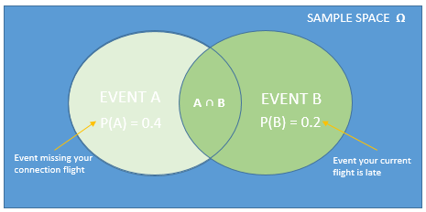
Here the event A ∩ B represent the event the current flight is late and you miss the connection flight.
Notice that there is still some area common to both events A and B. This is the event where your current flight is late and you miss your connecting flight.
Our initial objective was to find your probability of missing the connecting flight if your current flight is late ie the area shared by events A and B. This is mathematically represented by A ∩ B.
Going back to fundamental definition of probability,
P(Event) = number of favourable outcomes / all the possible outcomes
P(Event current flight is late and missing connection flight)=P(A ∩ B )/ P(B)
ie P(A|B) = P(A ∩ B )/ P(B)
You may have the question : why P(B) ?
This is because, in calculating the probability of the second event, we know that the event B has already occurred and out sample space reduces to the area enclosed by event B.

- Naïve Bayes Classifier Algorithm
- Naïve Bayes algorithm is a supervised learning algorithm, which is based on Bayes theorem and used for solving classification problems.
- It is mainly used in text classification that includes a high-dimensional training dataset.
- Naïve Bayes Classifier is one of the simple and most effective Classification algorithms which helps in building the fast machine learning models that can make quick predictions.
- It is a probabilistic classifier, which means it predicts on the basis of the probability of an object.
- Some popular examples of Naïve Bayes Algorithm are spam filtration, Sentimental analysis, and classifying articles.

Why is it called Naïve Bayes?
The Naïve Bayes algorithm is comprised of two words Naïve and Bayes, Which can be described as:
- Naïve: It is called Naïve because it assumes that the occurrence of a certain feature is independent of the occurrence of other features. Such as if the fruit is identified on the bases of color, shape, and taste, then red, spherical, and sweet fruit is recognized as an apple. Hence each feature individually contributes to identify that it is an apple without depending on each other.
- Bayes: It is called Bayes because it depends on the principle of Bayes' Theorem
.

Bayes' Theorem:
- Bayes' theorem is also known as Bayes' Rule or Bayes' law, which is used to determine the probability of a hypothesis with prior knowledge. It depends on the conditional probability.
- The formula for Bayes' theorem is given as:
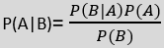
Where,
P(A|B) is Posterior probability: Probability of hypothesis A on the observed event B.
P(B|A) is Likelihood probability: Probability of the evidence given that the probability of a hypothesis is true.
Woman Trying to Surf With Wave Machine Falls Over Backwards and Faceplants to the Water
P(A) is Prior Probability: Probability of hypothesis before observing the evidence.
P(B) is Marginal Probability: Probability of Evidence.

Working of Naïve Bayes' Classifier:
Working of Naïve Bayes' Classifier can be understood with the help of the below example:
Suppose we have a dataset of weather conditions and corresponding target variable "Play". So using this dataset we need to decide that whether we should play or not on a particular day according to the weather conditions. So to solve this problem, we need to follow the below steps:
- Convert the given dataset into frequency tables.
- Generate Likelihood table by finding the probabilities of given features.
- Now, use Bayes theorem to calculate the posterior probability.
Problem: If the weather is sunny, then the Player should play or not?
Solution: To solve this, first consider the below dataset:
 | Outlook | Play
0 | Rainy | Yes
1 | Sunny | Yes
2 | Overcast | Yes
3 | Overcast | Yes
4 | Sunny | No
5 | Rainy | Yes
6 | Sunny | Yes
7 | Overcast | Yes
8 | Rainy | No
9 | Sunny | No
10 | Sunny | Yes
11 | Rainy | No
12 | Overcast | Yes
13 | Overcast | Yes
Frequency table for the Weather Conditions:
Weather | Yes | No
Overcast | 5 | 0
Rainy | 2 | 2
Sunny | 3 | 2
Total | 10 | 4
Likelihood table weather condition:
Weather | No | Yes
Overcast | 0 | 5 | 5/14= 0.35
Rainy | 2 | 2 | 4/14=0.29
Sunny | 2 | 3 | 5/14=0.35
All | 4/14=0.29 | 10/14=0.71
Applying Bayes'theorem:
P(Yes|Sunny)= P(Sunny|Yes)*P(Yes)/P(Sunny)
P(Sunny|Yes)= 3/10= 0.3
P(Sunny)= 0.35
P(Yes)=0.71
So P(Yes|Sunny) = 0.3*0.71/0.35= 0.60
P(No|Sunny)= P(Sunny|No)*P(No)/P(Sunny)
P(Sunny|NO)= 2/4=0.5
P(No)= 0.29
P(Sunny)= 0.35
So P(No|Sunny)= 0.5*0.29/0.35 = 0.41
So as we can see from the above calculation that P(Yes|Sunny)>P(No|Sunny)
Hence on a Sunny day, Player can play the game.

Advantages of Naïve Bayes Classifier:
- Naïve Bayes is one of the fast and easy ML algorithms to predict a class of datasets.
- It can be used for Binary as well as Multi-class Classifications.
- It performs well in Multi-class predictions as compared to the other Algorithms.
- It is the most popular choice for text classification problems.

Disadvantages of Naïve Bayes Classifier:
- Naive Bayes assumes that all features are independent or unrelated, so it cannot learn the relationship between features.

Applications of Naïve Bayes Classifier:
- It is used for Credit Scoring.
- It is used in medical data classification.
- It can be used in real-time predictions because Naïve Bayes Classifier is an eager learner.
- It is used in Text classification such as Spam filtering and Sentiment analysis.

K-Nearest Neighbor(KNN) Algorithm for Machine Learning
- K-Nearest Neighbour is one of the simplest Machine Learning algorithms based on Supervised Learning technique.
- K-NN algorithm assumes the similarity between the new case/data and available cases and put the new case into the category that is most similar to the available categories.
- K-NN algorithm stores all the available data and classifies a new data point based on the similarity. This means when new data appears then it can be easily classified into a well suite category by using K- NN algorithm.
- K-NN algorithm can be used for Regression as well as for Classification but mostly it is used for the Classification problems.
- K-NN is a non-parametric algorithm, which means it does not make any assumption on underlying data.
- It is also called a lazy learner algorithm because it does not learn from the training set immediately instead it stores the dataset and at the time of classification, it performs an action on the dataset.
- KNN algorithm at the training phase just stores the dataset and when it gets new data, then it classifies that data into a category that is much similar to the new data.
- Example: Suppose, we have an image of a creature that looks similar to cat and dog, but we want to know either it is a cat or dog. So for this identification, we can use the KNN algorithm, as it works on a similarity measure. Our KNN model will find the similar features of the new data set to the cats and dogs images and based on the most similar features it will put it in either cat or dog category.

Why do we need a K-NN Algorithm?
Suppose there are two categories, i.e., Category A and Category B, and we have a new data point x1, so this data point will lie in which of these categories. To solve this type of problem, we need a K-NN algorithm. With the help of K-NN, we can easily identify the category or class of a particular dataset. Consider the below diagram:
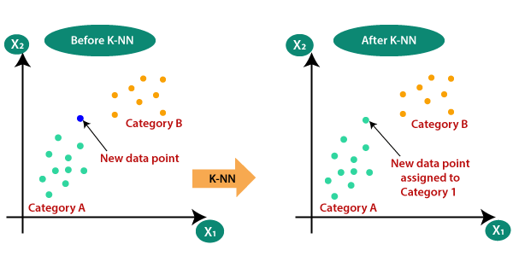

How does K-NN work?
The K-NN working can be explained on the basis of the below algorithm:
- Step-1: Select the number K of the neighbors
- Step-2: Calculate the Euclidean distance of K number of neighbors
- Step-3: Take the K nearest neighbors as per the calculated Euclidean distance.
- Step-4: Among these k neighbors, count the number of the data points in each category.
- Step-5: Assign the new data points to that category for which the number of the neighbor is maximum.
- Step-6: Our model is ready.
Suppose we have a new data point and we need to put it in the required category. Consider the below image:
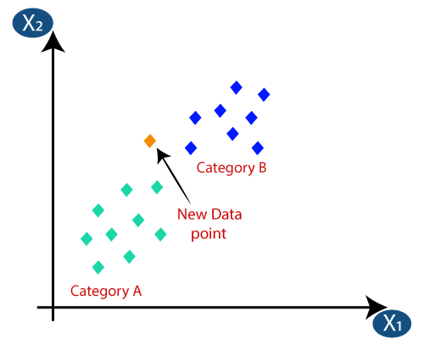
- Firstly, we will choose the number of neighbors, so we will choose the k=5.
- Next, we will calculate the Euclidean distance between the data points. The Euclidean distance is the distance between two points, which we have already studied in geometry. It can be calculated as:
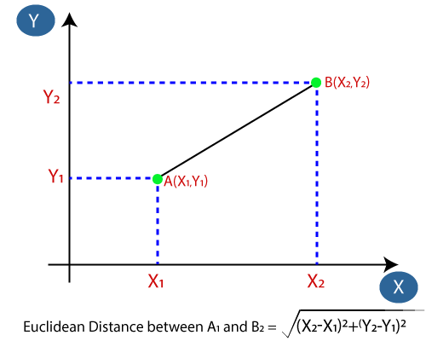
- By calculating the Euclidean distance we got the nearest neighbors, as three nearest neighbors in category A and two nearest neighbors in category B. Consider the below image:
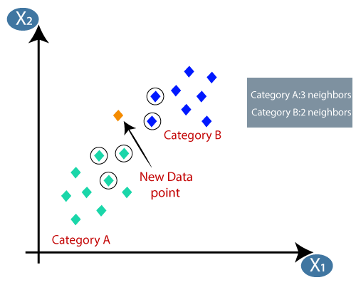
- As we can see the 3 nearest neighbors are from category A, hence this new data point must belong to category A.

How to select the value of K in the K-NN Algorithm?
Below are some points to remember while selecting the value of K in the K-NN algorithm:
- There is no particular way to determine the best value for "K", so we need to try some values to find the best out of them. The most preferred value for K is 5.
- A very low value for K such as K=1 or K=2, can be noisy and lead to the effects of outliers in the model.
- Large values for K are good, but it may find some difficulties.

Advantages of KNN Algorithm:
- It is simple to implement.
- It is robust to the noisy training data
- It can be more effective if the training data is large.

Disadvantages of KNN Algorithm:
- Always needs to determine the value of K which may be complex some time.
- The computation cost is high because of calculating the distance between the data points for all the training samples.

